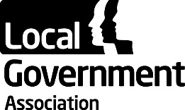 | Councillors’ Forum
 | 19 October 2017

Appendix A

The Rt. Hon. Brandon Lewis MP

Minister of State for Immigration

The Rt. Hon. Brandon Lewis was appointed Minister of State for Immigration on 11 June 2017. Prior to this, he held a number of ministerial positions: he was appointed as the Parliamentary Under Secretary of State at the Department for Communities and Local Government from September 2012 until July 2014. He also served as Minister of State for Housing and Planning at the Department for Communities and Local Government from July 2014 until July 2016.

Mr Lewis was first elected as the Conservative MP for Great Yarmouth in 2010. Before becoming an MP, he was an active member of a number of all-party parliamentary groups, including those for enterprise zones and local growth, as well as local government. He was co-chair of a group on coastal erosion and continues to work with colleagues who represent other coastal towns to highlight common issues in their constituencies. Mr Lewis also served on Brentwood Borough Council for more than ten years and was Leader of the Council for five of those years.

Mr Lewis was born in Havering in 1971, and attended the Forest School in Walthamstow. He went on to study for a BSc Economics and LLB Hons (Law) at the University of Buckingham. He also holds an LLM in commercial law from King’s College London and is a qualified barrister and company director.

